## Accusations Against Believers

The believer is prohibited from judging other believers. Judging always has a bad connotation in Scripture. However, a believer is to discern. Matt. 7:1-2, Rom. 14:4-10, 1 Cor. 2:15.

““Do not judge so that you will not be judged. “For in the way you judge, you will be judged; and by your standard of measure, it will be measured to you.”  (Matthew 7:1-2, NASB)

“But he who is spiritual appraises all things, yet he himself is appraised by no one.”  (1 Corinthians 2:15, NASB)

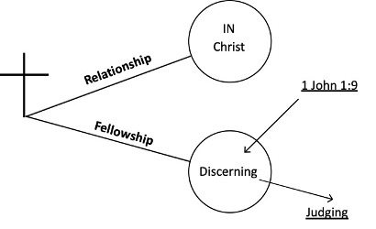

A believer in fellowship can evaluate and discern based on their frame of reference that references the *epignosis* Bible doctrine in the soul. However, a believer out of fellowship will always be judging. Their own sin nature will control their thoughts and speech pattern. Every believer must live their life as unto the Lord. However, parents have jurisdiction over their children. Every believer has the right of privacy before the Lord. God judges believers for judging others and for carnality. Heb. 12:6

“FOR THOSE WHOM THE LORD LOVES HE DISCIPLINES, AND HE SCOURGES EVERY SON WHOM HE RECEIVES.”“ (Hebrews 12:6, NASB)

A believer is to leave all discipline in the hands of the Lord. The corrected translation is: “Who shall bring any accusation against the elect of God?” The answer is no one! Rom. 8:33.

“Who will bring a charge against God’s elect? God is the one who justifies;”  (Romans 8:33, NASB)

Satan is actually the accuser of all believers. A believer must be able to distinguish between the accusing ministry of Satan and the convicting ministry of the Holy Spirit. Rev. 12:10.

“Then I heard a loud voice in heaven, saying, “Now the salvation, and the power, and the kingdom of our God and the authority of His Christ have come, for the accuser of our brethren has been thrown down, he who accuses them before our God day and night.” (Revelation 12:10, NASB)